

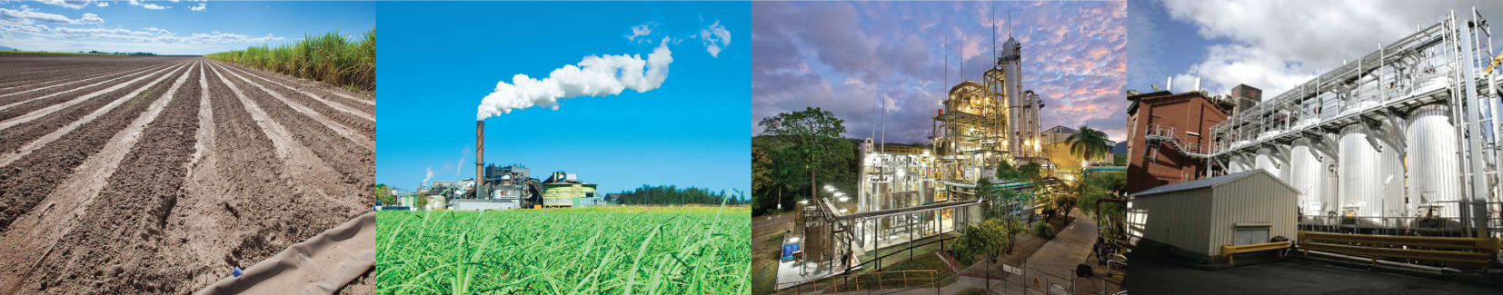

Response to Request for Proposal –

Contract Spraying Herbert
Wilmar Sugar Australia
Date

Table of contents

1. Company details, licenses and insurances 3
2. Equipment to be supplied by contractor 4
3. Pricing 4
4. Contractor – Confirm can meet minimum requirement 4

Organisations must submit their queries and responses in writing addressing all the criteria and providing all the information required by this document to the following e-mail address:
E-mail address: cameron.barber@au.wilmar-intl.com
A hard copy can be sent/delivered to the following address;
Cameron Barber
Wilmar Sugar
Victoria Mill
PMB1
Ingham QLD 4850

All proposals must be received into the above email address by close of business on the 6th March 2023.

Company details, licenses and insurances
A.1 - Company Information |  | Please supply details
A.1.1 | Official registered company name (Corporate, D.B.A., parnership, etc.)
A.1.2 | Name of Contact Person
A.1.3 | Contact Phone Number
A.1.4 | Contact Email Address
A.1.5 | Position of Person Completing this RFP
A.1.6 | ABN number
A.1.7 | Company Street Address
A.1.8 | City
A.1.9 | Country
A.1.10 | Postal Code
A.1.11 | Company Website Address (if available)
A.1.12 | Does your organisation have any existing contractual arrangements with Wilmar?
A.1.13 | Person authorized to contractually bind the organization for any proposal against this RFP.

A.2 - Licenses |  |  | Please confirm you have the following licenses and attach proof.
A.2.1 | Licensed Ground Distribution Contractor Number
 | List Licensed Commercial Operators and their license number
A.3 - Insurances |  |  |  | Please confirm you have the following insurances and attach proof.
A.3.1 |  | Public Liability (Min $20M cover)
A.3.2 |  | Motor Vehicle (comprehensive third party liability damage, loss) (Min cover $20M)
A.3.3 |  | General Products Liability (Min $20M cover)
A.3.4 |  | Worker's Compensation (as per state legislation)

Pricing
Application method | $/ha (excluding GST)
Broadcast spraying
Directed Spraying

Equipment to be supplied by contractor
Item | Description | Equipment details - Age (hours and/or years)
Example Tractor | JD 8130 FWA | 3 year – 5000 hours
Spray rig
Water truck
Mixing facilities
Equipment

Contractor – Confirm can meet minimum requirement
Contractor to confirm they can meet these requirements | Circle
Safety:  - Meet Wilmar’s safety and environmental guidelines including but not limited to:  - Working within Wilmar Sugar safety management system and demonstrate processes for ensuring safety  - Mobile mixing equipment to have safety showers and eye-wash facilities.  - Closed tank mixing system | Yes / No  Yes / No  Yes / No  Yes / No
Equipment will meet the following:  - Section controlled boom with the ability to apply chemical over the top (broadcast) and directed (legs)  - Have technology in the spray rig with the ability to apply variable rate chemicals, GPS guidance, digitally record of spray records and supply digital records of all spray operations in a format compatible to Trimble Agricultural Software.  - Spray chemicals on controlled traffic 1.8 m row spacing in a directed manner | Yes / No  Yes / No  Yes / No  Yes / No
Meet the following operational requirements/KPI’s:  - Apply chemicals to Smartcane BMP standard.  - Work with Wilmar’s staff including the Operations Manager and/or Agronomist to undertake the application of chemicals within a specified window and timely manner.  - Communicate daily or as required the following to the Operations Manager:  - Progress of works  - Any changes in conditions  - Changes in chemical requirements  - Undertake regular inspections with Wilmar’s Operations Manager to assess and report application quality and have the ability to quickly rectify issues.  - Load sheets to be completed on the day of application and supplied at the end of each week or when requested; preferably in a digital format.  - Every month supply a complete digital copy of all spray application records for uploading into Trimble Ag Software | Yes / No  Yes / No  Yes / No  Yes / No  Yes / No  Yes / No  Yes / No  Yes / No
Enter into a contract for the supply of these services | Yes / No

Name of person authorized to complete the RFP on behalf of the company:

Signature

Date

